ODD AND EVEN
OCR GSCE – Tuesday 11 June 2019 – Paper 6 (Calculator) Higher Tier
1.
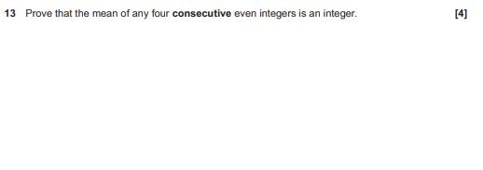
OCR GSCE – Thursday 8 June 2017 – Paper 5 (Non - Calculator) Higher Tier
2.
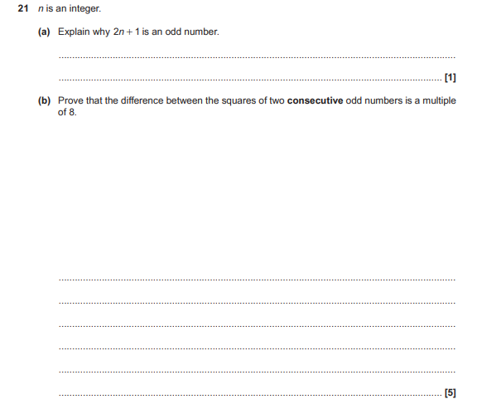
OCR GSCE – Sample Papers – Paper 4 (Calculator) Higher Tier
3.
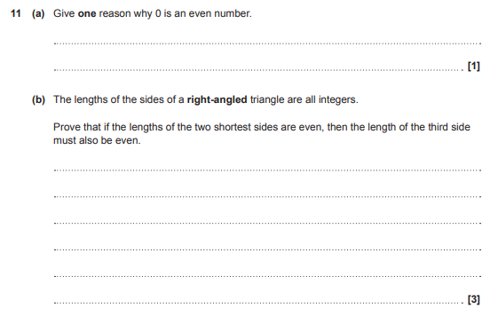

OCR GSCE – Sample Papers – Paper 6 (Calculator) Higher Tier
4.
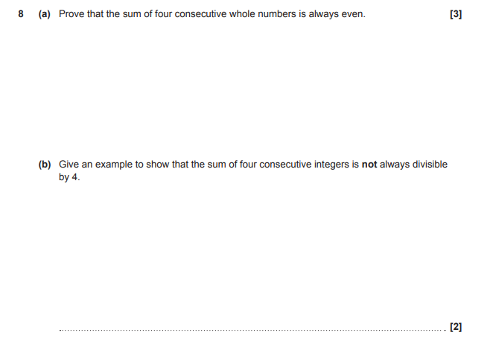

AQA GSCE – Thursday 6 June 2019 – Paper 2 (Calculator) Higher Tier
5.
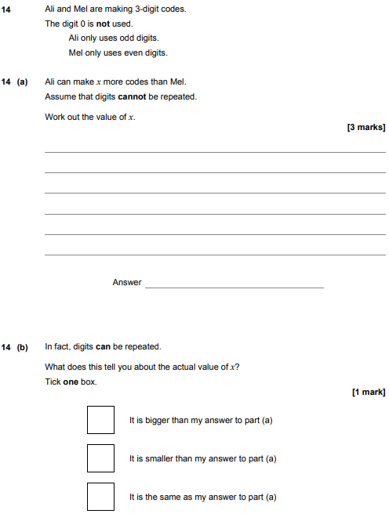

AQA GSCE – Thursday 8 November 2018 – Paper 2 (Calculator) Higher Tier
6.
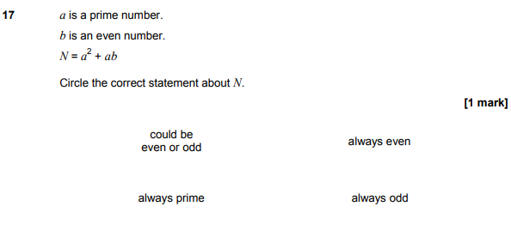
AQA GSCE – Sample Paper 2 (Calculator) Higher Tier
7.
